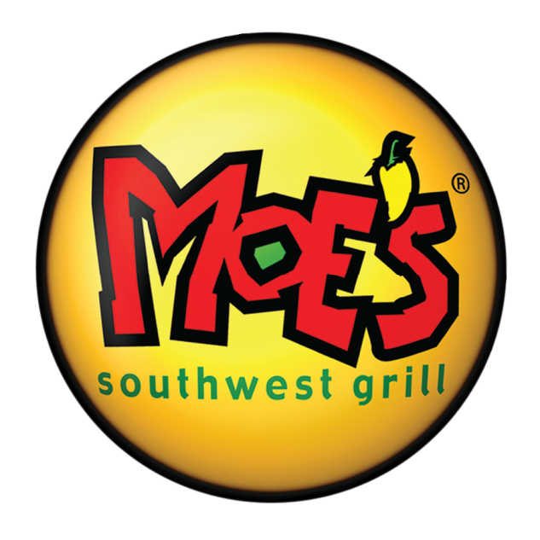
INSERT GROUP LOGO or NAME

EAT AT MOE’S
and support your group!
{INSERT NAME OF GROUP}
is having a fundraiser at:
Moe’s Southwest Grill, 3150 Route 22 West
Branchburg, NJ 08876
(Near Raritan Valley Community College and ShopRite)
DATE: {Insert Date}
TIME: {Insert Time}

15% of net sales will go to your group!
Bring this flyer and present it to the cashier.

*Promotion not valid with any discount or coupon. Promotion only valid for date and time listed.

